Offer/2023-24/63 Date: 27-Dec-2023.

To,

The Executive Engineer,

(Engineer In-charge)

TSMSIDC,

Hyderabad Division.

Sub: Quotation Submission for Gandhi Hospital.

Ref: your enquiry dated 11-12-2023.

Dear Sir,

Attached herewith is our quotation for Gandhi Hospital. The prices quoted cover a 5-year warranty, and CAMC prices for the 6th to 10th year are detailed separately as per your request.

Your consideration of our proposal is highly appreciated.

Thank you.

Yours Faithfully,

Authorized Signatory

|  |  |  |  |  |  |  |
| --- | --- | --- | --- | --- | --- | --- |
| **S.No** | **Description** | **QTY** | **UOM** | **Unit Rate (Rs.)** | **Amount (Rs.)** | **CAMC Amount for 5th year to 10th year** |
| 1 | Supply and installation of 50mm thick double skin modular wall Panels made of 0.8 mm thick powder coated GI on both the sides, with 40 plus or minus 2 kg/m3 density PUF as infill, GI profiles all along the periphery, flush on both sides with maximum allowable gap of 3- 4mm filled with food grade silicon sealant and placed on cold rolled galvanised bottom tracks with a recess to provide floor to wall coving flush with the wall panel. This includes all required harware for completion Panels to be covered with a protective film to avoid any damages during transportation and installation | 297.5 | Sqm | 7,450 | 22,16,524.00 | 8,86,609.60 |
| 2 | Supply and installation of 50mm thick double skin ceiling system made of 0.8 mm thick Powder Coated GI sheets on both sides, 40 plus or minus 2 kg/m3 density PUF as infill, GI profiles all along the periphery, panels flush towards room side with maximum allowable gap of 3-4mm at panel to panel joints filled with silicon sealant. Ceiling panels are suspended from the RCC slab by using concealed AL ceiling grid with tie rod and adjustable turn buckle arrangement etc. This includes all required hardware for completion. Panels to be covered with a protective film to avoid any damages during transportation and installation | 163.1 | Sqm | 7,450 | 12,14,946.00 | 4,85,978.40 |
| Total Amount | | | | | **34,31,470.00** | **13,72,588.00** |
| GST @ 18% | | | | | **6,17,664.60** |  |
| Total Amount excluding CAMC | | | | | **40,49,134.60** |  |
| CAMC Amount as per below table | | | | | **13,72,588.00** |  |
| Total Amount including CAMC Amount | | | | | **54,21,722.60** |  |
| Comprehensive Annual Maintanance Charges post warranty period for 5 years (6th year to 10th year) @ 8,8,8,8,8 % respectivel     |  |  |  |  | | --- | --- | --- | --- | | Base Price | | | **34,31,470.00** | | **S.No** | **Year** | **CAMC %** | **Amount** | | 1 | 6th | 8% | 2,74,517.60 | | 2 | 7th | 8% | 2,74,517.60 | | 3 | 8th | 8% | 2,74,517.60 | | 4 | 9th | 8% | 2,74,517.60 | | 5 | 10th | 8% | 2,74,517.60 | | Total % | | 40% |  | | Total Amount | | | **13,72,588.00** | | | | | | | |

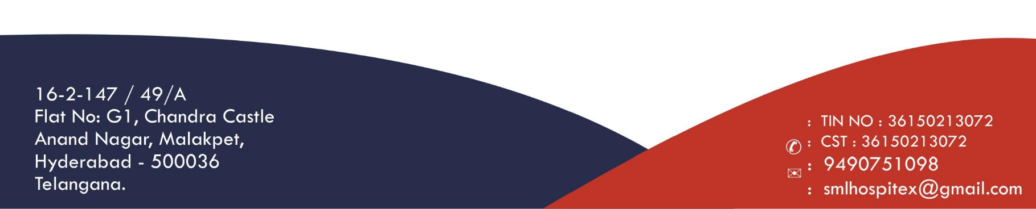

For